App Dev Project Report

1. Student Details
Name: K Anandi Raghavi
Roll No: 23F3002074
Email ID: 23f3002074@ds.study.iitm.ac.in
I’m a 3rd Year CSE Student in GNITS, Hyderabad. I’m an enthusiast of technology and love exploring new fields to gain knowledge.

2. Project Details

Project Title: An integrated placement portal for companies, students, educational institutions

Problem Statement:

To design and implement a web-based placement portal that connects students, companies, and administrators. The system should allow companies to post placement drives, students to apply for opportunities, and administrators to manage approvals, applications, and overall placement activity efficiently.

Approach:
The application was built using a Flask REST API backend and a Vue.js frontend. The backend handles authentication, database operations, and business logic using SQLAlchemy ORM. The frontend provides a responsive and interactive user interface using Vue components.
The system supports three roles:
- Admin – manages students, companies, placement drives, and applications
- Company – creates placement drives and evaluates applicants
- Student – browses placement drives and submits applications

3. AI/LLM Declaration
I used ChatGPT (GPT-5) to assist with concept clarification, debugging suggestions, and improving code structure during development. The AI assistance was primarily limited to understanding framework usage (Flask, Vue.js, Celery) and refining API logic.
Most of the application logic, feature integration, debugging, and UI implementation were performed manually.
The overall AI-assisted portion is estimated to be around 15%, primarily related to development guidance and code suggestions rather than direct code generation.
All final implementation, integration, and testing were completed independently.

4. Technologies and Frameworks Used
Technology / Library | Purpose
Flask | Backend web framework for building REST APIs
SQLAlchemy | ORM for database interaction
SQLite | Database used to store users, drives, and applications
Flask-JWT-Extended | Token-based authentication
Flask-Migrate | Database schema migrations
Flask-Mail | Email notifications for reminders and reports
Celery | Asynchronous task processing
Redis | Message broker for Celery
Vue.js | Reactive frontend framework
Axios | API communication between Vue frontend and Flask backend
Bootstrap | UI styling and responsive design
CSV Module (Python) | Exporting student application history

5. Database Schema / ER Diagram
Tables
User
Fields:
- id
- name
- email
- password
- role (admin / student / company)

Student
Fields:
- id
- user_id
- branch
- cgpa
- year
Company
Fields:
- id
- user_id
- company_name
- approval_status

PlacementDrive
Fields:
- id
- company_id
- job_title
- job_description
- cgpa_eligibility
- branch_eligibility
- year_eligibility
- application_deadline
- status

Application
Fields:
- id
- student_id
- drive_id
- status
- application_date

MonthlyReport
Fields:
- id
- total_drives
- total_applications
- total_selected
- html_content
- generated_date

Relationships
One-to-Many → User → Student
One-to-Many → User → Company
One-to-Many → Company → PlacementDrive
One-to-Many → Student →Application
One-to-Many → PlacementDrive → Application
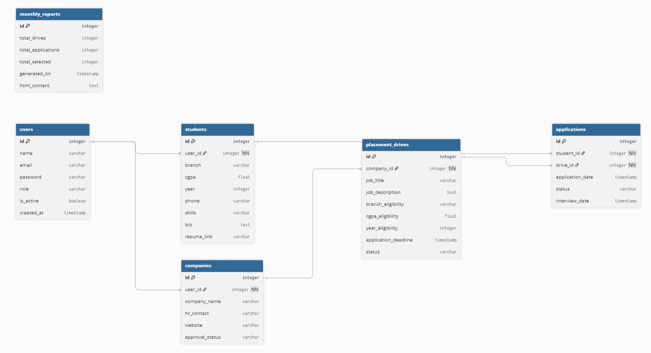

6. API Resource Endpoints
Endpoint | Method | Description
/api/auth/login | POST | Authenticate user and generate JWT token
/api/auth/register/student | POST | Register a new student
/api/auth/register/company | POST | Register a new company
/api/student/drives | GET | Fetch available placement drives
/api/drive/apply | POST | Apply to a placement drive
/api/student/placement_history | GET | View student application history
/api/student/export | POST | Export application history as CSV
/api/company/create_drive | POST | Create a new placement drive
/api/company/drives | GET | View company drives
/api/company/applicants/{drive_id} | GET | View applicants for a drive
/api/company/application/update/{id} | PUT | Update application status
/api/admin/dashboard | GET | Fetch admin dashboard statistics
/api/admin/companies | GET | View registered companies
/api/admin/approve/company/{id} | PUT | Approve company
/api/admin/reject/company/{id} | PUT | Reject company
/api/admin/drives | GET | View placement drives
/api/admin/approve/drive/{id} | PUT | Approve drive
/api/admin/students | GET | View students
/api/admin/applications | GET | View all applications
/api/admin/search/students | GET | Search students
/api/admin/search/companies | GET | Search companies
/api/admin/reports | GET | Fetch monthly reports

7. Architecture and Features

Architecture Overview

Backend

Flask REST API

SQLAlchemy ORM

Flask Blueprints for modular routing

JWT authentication

Frontend

Vue.js SPA

Axios API communication

Background Processing

Celery workers

Redis message broker

Database

SQLite with migrations managed by Flask-Migrate

Implemented Features:
- Student registration and login
- Company registration and approval workflow
- Placement drive creation
- Eligibility filtering for applications
- Student and company search functionality
- CSV export of application history
- Email reminders for upcoming drive deadlines
- Monthly placement reports for admin
- Role-based access control

8. Video Presentation
Drive Link:
https://drive.google.com/file/d/1_w5MzgF-CtJgoQMNmlMOv4tqN0cWJzj0/view?usp=sharing

